Q. Demonstrate HTTP Server in Packet Tracer.

Aim: To configure a web server and test web page access from clients using web browsers.
Steps:
1.In packet tracer place 1 Server-PT and 2 PC-PT and 1 Switch.
2.Connect Server-PT with Switch via FastEthernet0 using straight-through copper cord.
3.Connect PC-PT0 and PC-PT1 with Switch via FastEthernet0 using straight-through copper cords.
4.Set the IP address of Server-PT and both PCs in IP configuration.
5.Configure HTTP service on Server-PT and create web pages.
6.Test web access from both PCs. Topology:
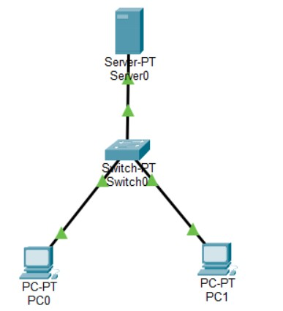

Code:
Server-PT Configuration:
IP Address: 192.168.1.10
Subnet Mask: 255.255.255.0
Default Gateway: 192.168.1.1 HTTP Service Configuration:
HTTP Service: ON
Created web pages: index.html, about.html, courses.html

index.html:
html
<!DOCTYPE html>
<html>
<head>
<title>My College Website</title>
</head>
<body>
<h1>Welcome to College Server</h1>
<p>This website is hosted on Server-PT in Packet Tracer.</p>
<a href="about.html">About College</a> |
<a href="courses.html">Courses</a>
</body>
</html>

about.html:
html
<!DOCTYPE html>
<html>
<head>
<title>About Our College</title>
</head>
<body>
<h1>About Our Institution</h1>
<p>Established in 1990, we provide quality technical education.</p>
<p><b>Departments:</b> Computer, IT, Electronics, Mechanical</p>
<a href="index.html">Home</a> |
<a href="courses.html">Our Courses</a>
</body>
</html>

courses.html:
html
<!DOCTYPE html>
<html>
<head>
<title>College Courses</title>
</head>
<body>
<h1>Available Courses</h1>
<ul>
<li>Computer Engineering</li>
<li>Information Technology</li>

<li>Electronics & Telecommunication</li>
<li>Mechanical Engineering</li>
</ul>
<a href="index.html">Home</a> |
<a href="about.html">About College</a>
</body>
</html>

PC-PT0 Configuration:
IP Address: 192.168.1.20
Subnet Mask: 255.255.255.0 Default Gateway: 192.168.1.1 PC-PT1 Configuration:
IP Address: 192.168.1.30
Subnet Mask: 255.255.255.0
Default Gateway: 192.168.1.1 Verification: In Both PCs Web Browser PC-PT0:
Open Web Browser
Enter URL: http://192.168.1.10
Enter URL: http://192.168.1.10/about.html Enter URL: http://192.168.1.10/courses.html PC-PT1:
Open Web Browser
Enter URL: http://192.168.1.10
Enter URL: http://192.168.1.10/about.html Enter URL: http://192.168.1.10/courses.html Connectivity Test:
C:\>ping 192.168.1.10

Output:
Ping Test Results:

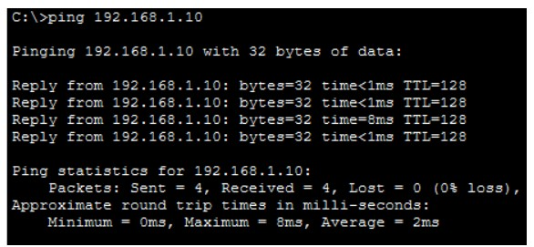

Pc1 :
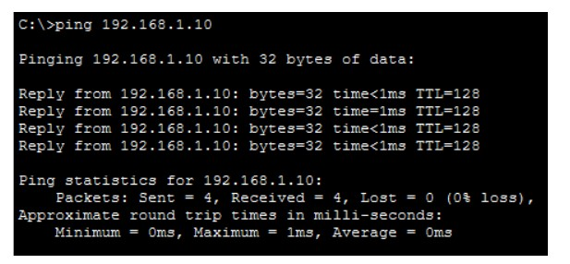

Output:
Homepage (http://192.168.1.10): Pc01
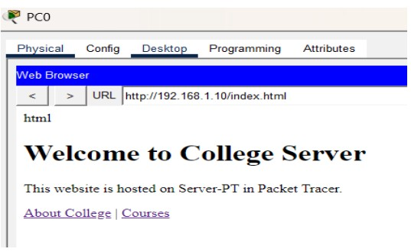

Pc1 :
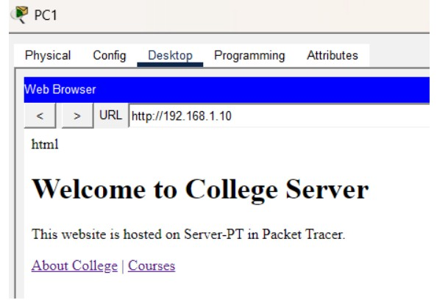

About Page (http://192.168.1.10/about.html): Pc0 :
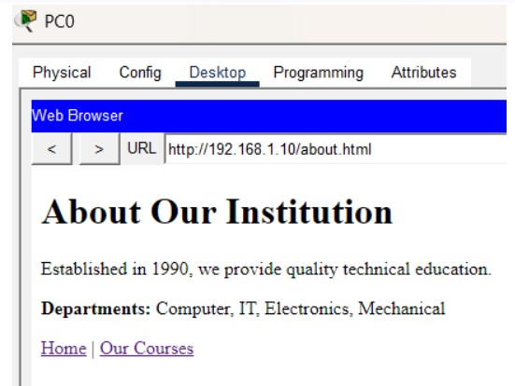

Pc1
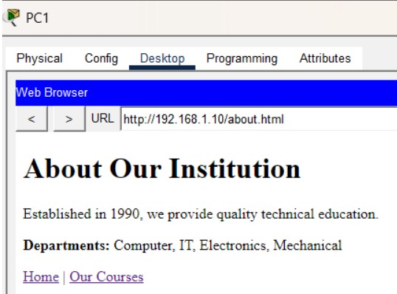

Courses Page (http://192.168.1.10/courses.html):

Pc0
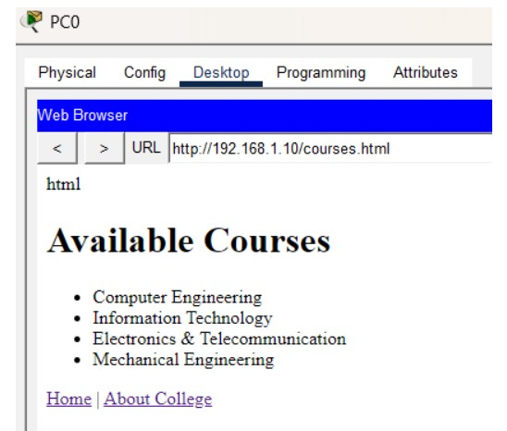

Pc1
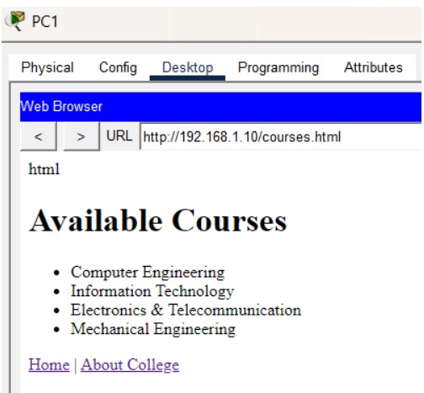

Conclusion: The HTTP web server has been configured successfully on Server-PT.

SIWS COLLEGE

